# Coursework

if a sentence is in red italics, I expect to see a written response

For sentences formatted bold I expect to see a plot.

answer the advanced parts well, which require some critical interpretation of

the results.

1. Please use at least 2 cm margins and 10 pt fonts
2. plots are high-quality, reasonably sized axis labels
3. All plots should have clear x- and y-axis labels, and units
4. whatever programming language
5. submit both your report and code (final mark will entirely be based on the report)

# Exam

is closed book

is in person

is handwritten

allows calculator

* There are 12 compulsory short questions.
* In addition, there are 3 long questions. You pick 2 of the 3 long questions. The long questions is really just a collection of a few short answer questions, but where there can be some links across the questions.
* Previous years have multiple choice questions and short answer questions, while this year we just have short answer questions (remember that the long questions are really just a collection of shorter questions). Importantly, the content + difficulty of the MCQs vs short answer questions should be very similar.

Section 1: Brain basics (14 marks)

Section 2: Differential equations, leaky integrate-and-fire

neurons (14 marks)

Section 3: Hodgkin Huxley, modelling neurons, analysing

spiking data (16 marks)

Section 4: Synapses, synaptic plasticity (7 marks)

Section 5: Hippocampus, Hopfield networks (14 marks)

Section 6: Visual system, rate coding (14 marks

Section 7: Supervised learning, Cerebellum, temporal

difference learning (7 marks)

# Week 1

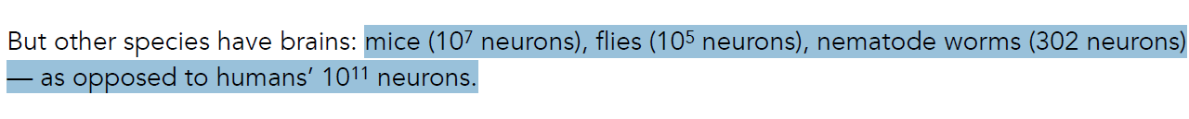

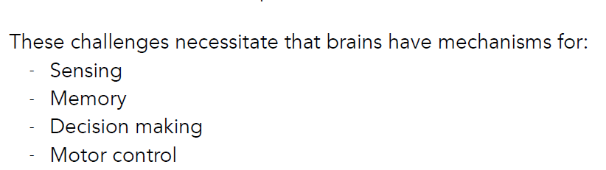

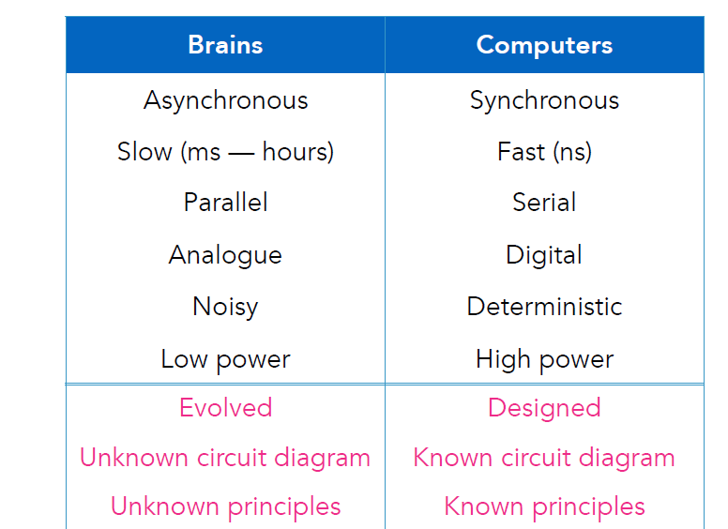

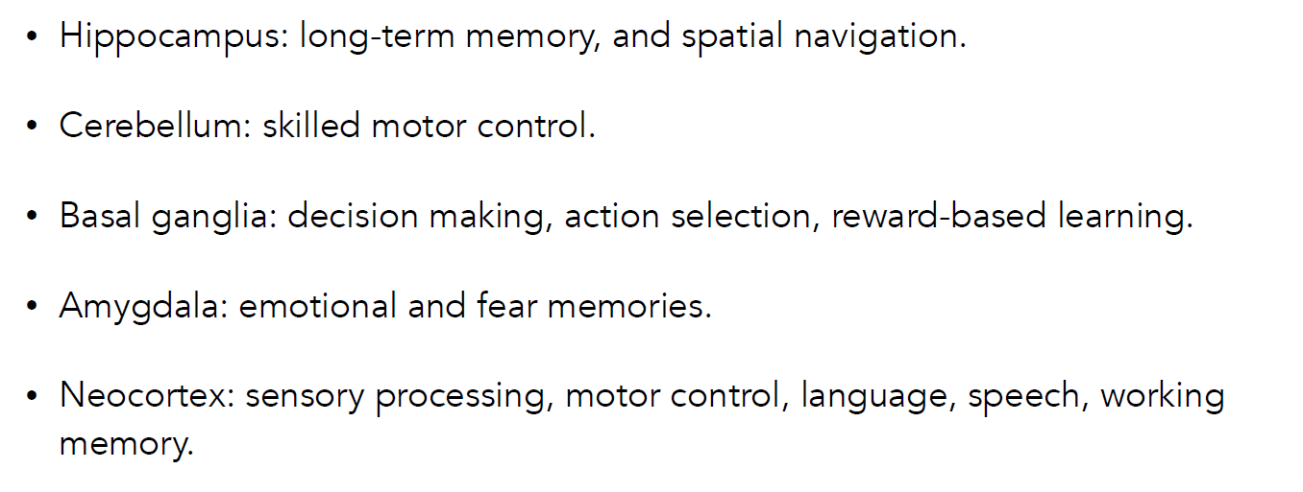

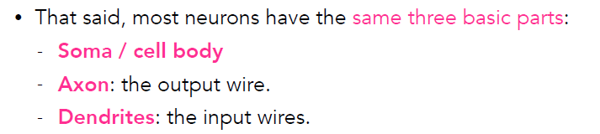

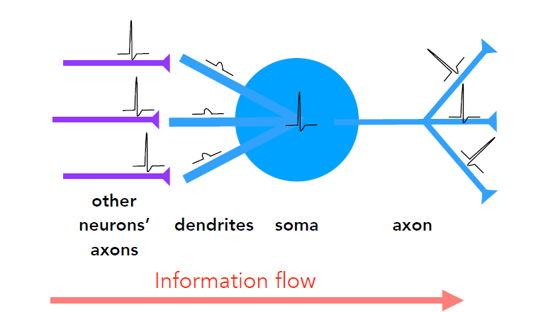

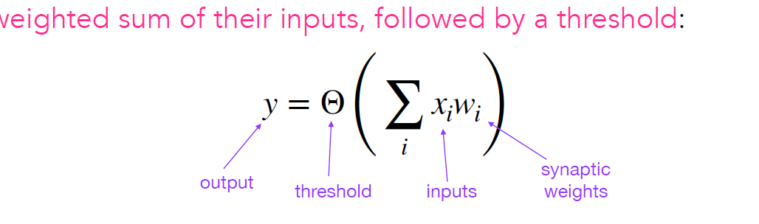

# Week 2

漏桶算法(Leaky Bucket)



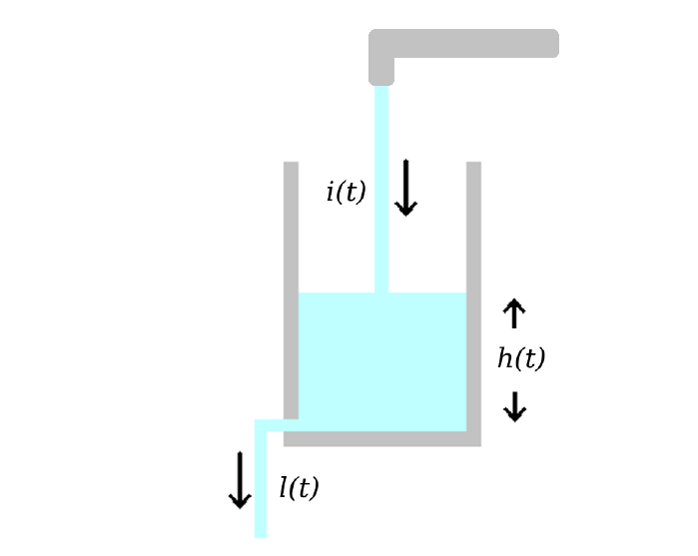

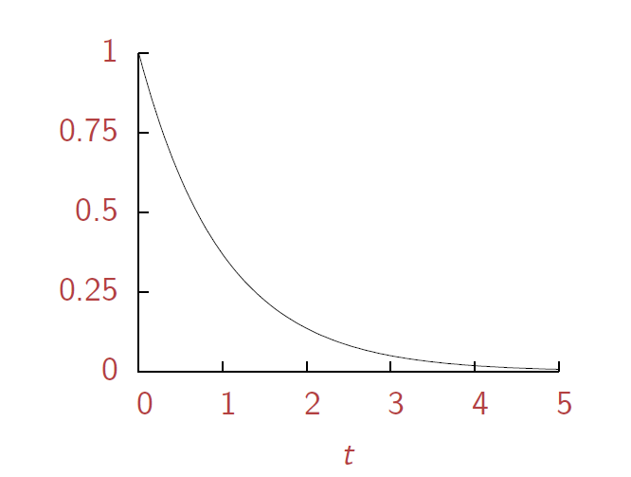

Linear Regression Exponential  指数函数 微分方程 （differential equations）

# Week 3

leaky integrate and fire model

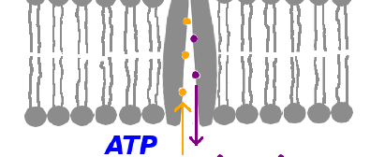

The ion pump pumps three sodium ions out for each it two potassiums it pumps in

**钠钾泵**（sodium–potassium pump）又称**钠钾ATP酶**（Na+/K+-ATPase）、**钠钾ATP酶泵**（sodium-potassium ATPase pump）, 是一种位于[细胞膜](https://zh.wikipedia.org/wiki/%E7%B4%B0%E8%83%9E%E8%86%9C)上，利用ATP水解把钠离子泵出，而把钾离子泵入细胞的一种[酶](https://zh.wikipedia.org/wiki/%E9%85%B6)（EC 3.6.3.9）；精确说，是一种“离子匣式跨膜[ATP酶](https://zh.wikipedia.org/wiki/ATP%E9%85%B6)”。钠钾泵可在人类细胞及[后生动物](https://zh.wikipedia.org/wiki/%E5%90%8E%E7%94%9F%E5%8A%A8%E7%89%A9)中发现，是维持细胞膜电位的重要酶。

钠钾泵可以将细胞外相对细胞内较低浓度的[钾离子](https://zh.wikipedia.org/wiki/%E9%89%80%E9%9B%A2%E5%AD%90)送进细胞，并将细胞内相对细胞外较低浓度的[钠离子](https://zh.wikipedia.org/wiki/%E9%88%89%E9%9B%A2%E5%AD%90)送出细胞

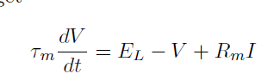

hodgkin_huxley 基于电导模型

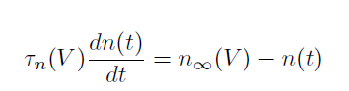

https://en.wikipedia.org/wiki/Biological_neuron_model

Hodgkin–Huxley

Perfect Integrate-and-fire

Leaky integrate-and-fire

Adaptive integrate-and-fire

Fractional-order leaky integrate-and-fire

'Exponential integrate-and-fire' and 'adaptive exponential integrate-and-fire'

# Week 4

Chemical synapses 化学突触

Post-synaptic potential 突觸後電位

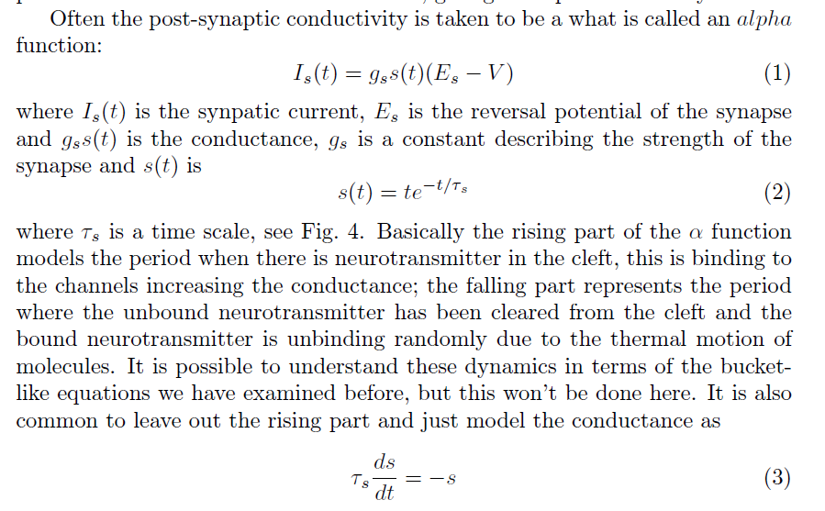

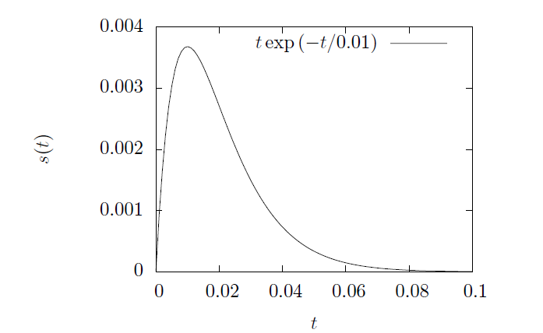

Synaptic plasticity 突触可塑性

神经元突触连接的长时间改变的能力

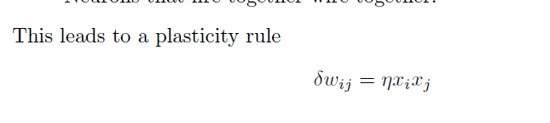

STDP Spike-timing dependent plasticity

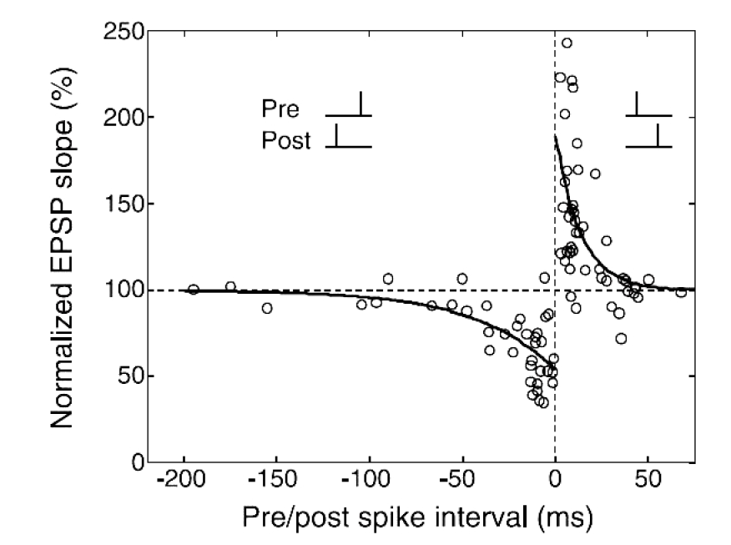

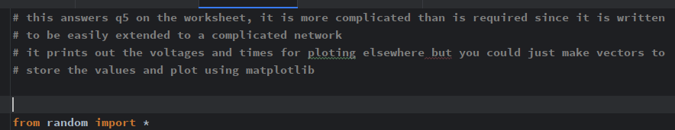

# Week 5

Hippocampus 海马体

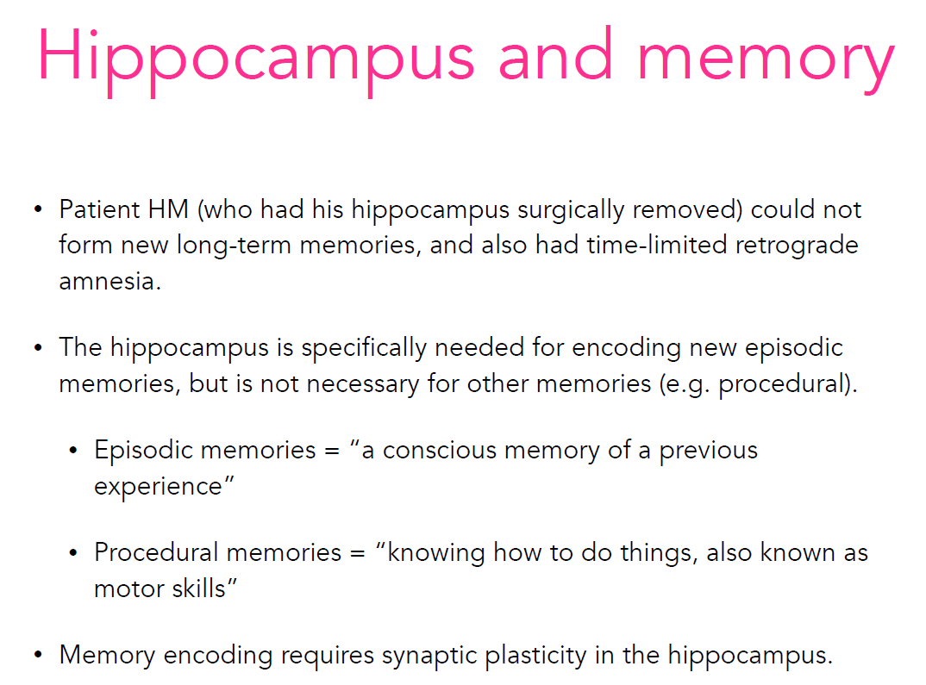

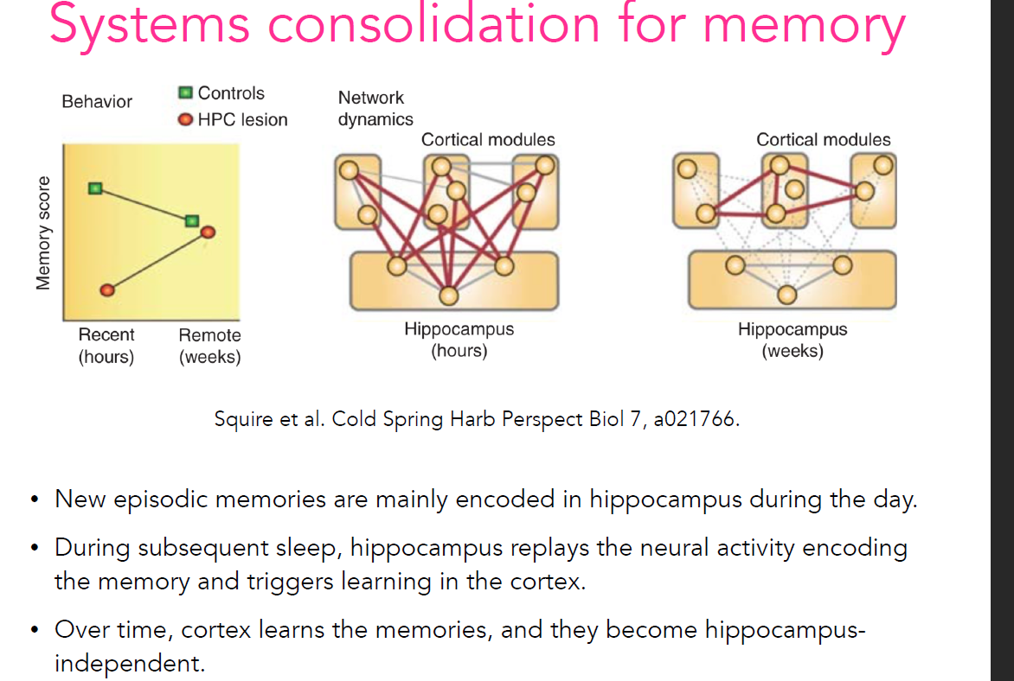

2.Hopfield Networks反馈神经网络

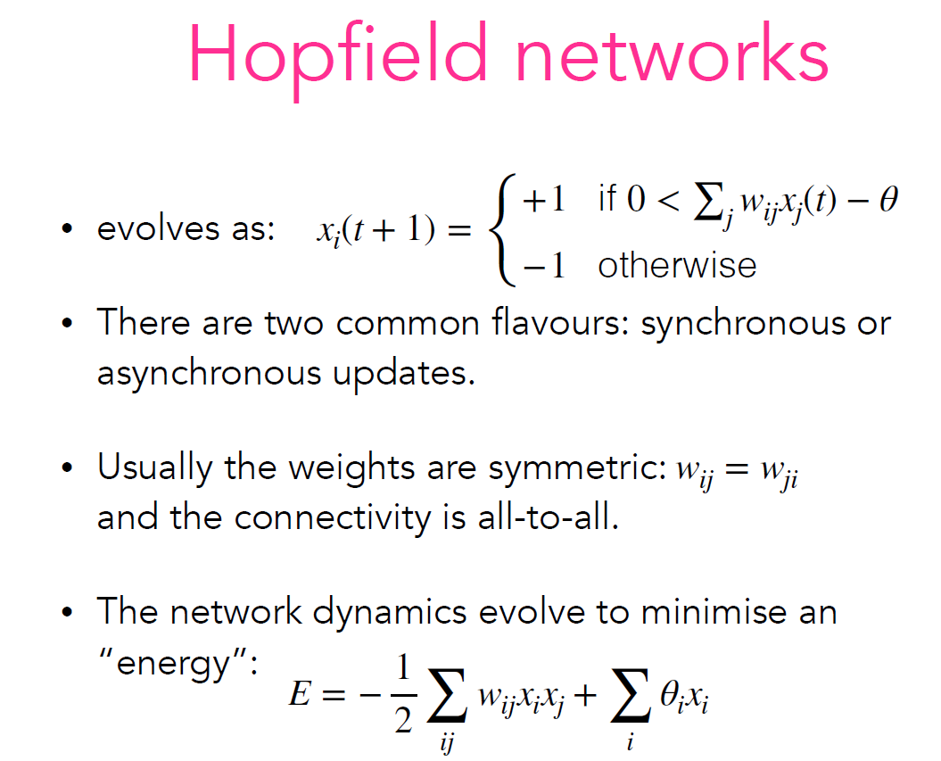

<https://zhuanlan.zhihu.com/p/116908556>

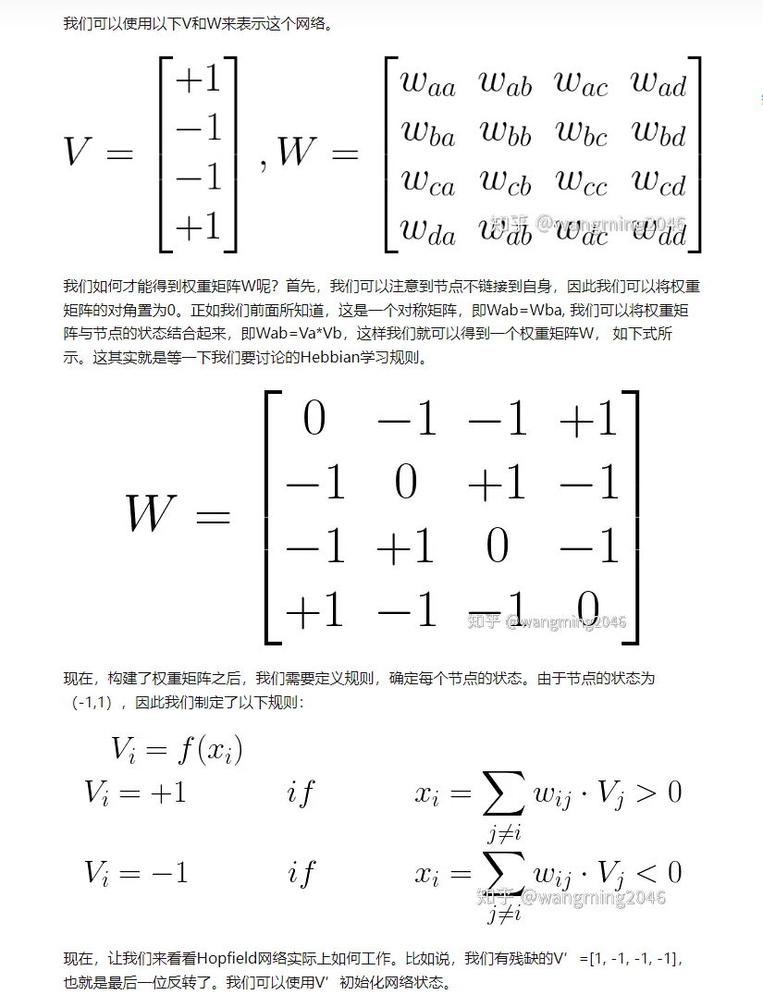

# Week 6

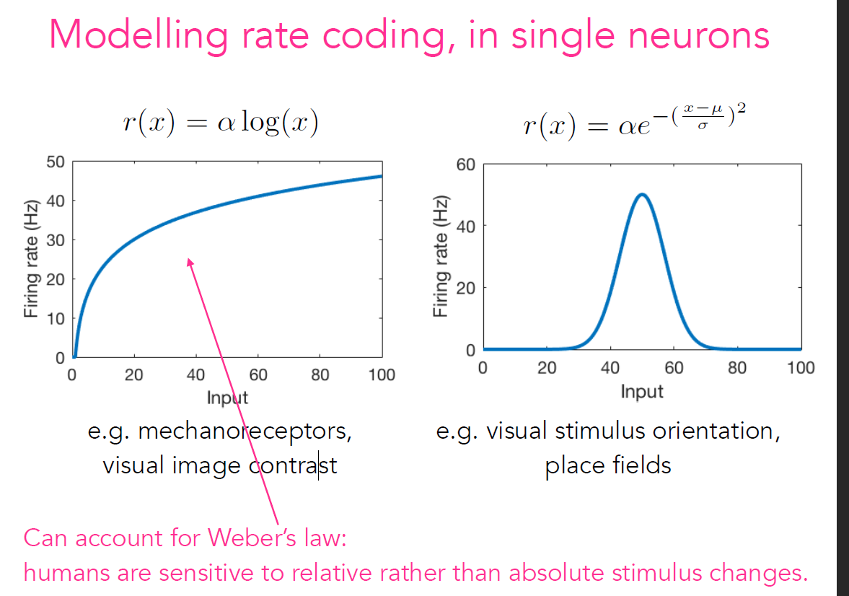

韦伯定律

人类对相对而非绝对刺激变化敏感。

In imaging science, difference of Gaussians (DoG)

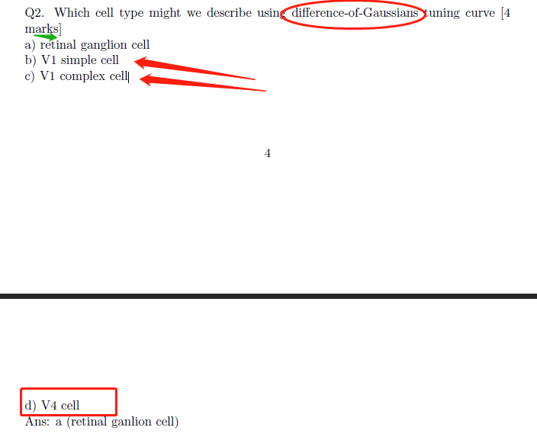

# Week 7

The delta rule

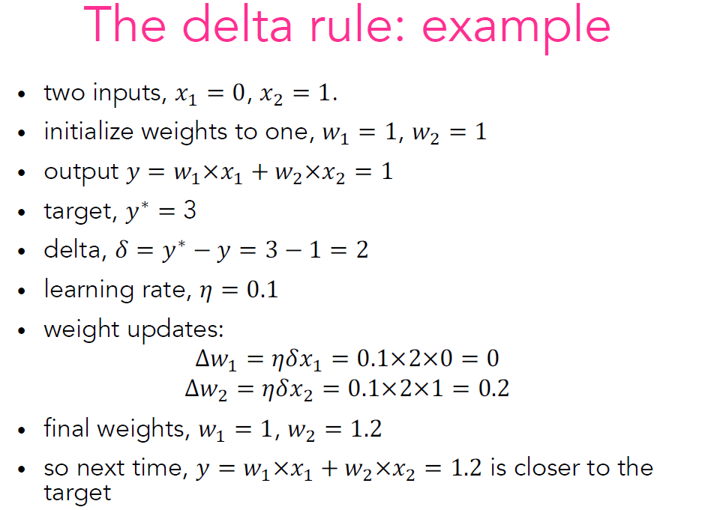

这是在机器学习中经常出现的更新规则。假设我们有一个目标，我们现在要逐步调整当前状态，令它慢慢趋近这个目标。方法是：其中 𝛼 叫学习速率，是一个 0 到 1 之间的小数。Delta(Δ) 指的是目标和现状的差异。

显然，反复执行上式，当前状态就会逐步逼近目标。